**Lesson 2: Gazebo**

**2.1 Introduction**

Robot simulation is an essential tool in every roboticist's toolbox. A well-designed simulator makes it possible to rapidly test algorithms, design robots, perform regression testing, and train AI system using realistic scenarios. Gazebo offers the ability to accurately and efficiently simulate populations of robots in complex indoor and outdoor environments. At your fingertips is a robust physics engine, high-quality graphics, and convenient programmatic and graphical interfaces.

**2.2 Installing GAZEBO**

Default Installation(one liner):

Install



curl -sSL http://get.gazebosim.org | sh

Run



Gazebo

Alternative installation(step-by-step):

Setup your computer to accept software from packages.osrfoundation.org.



Sudosh -c 'echo "deb http://packages.osrfoundation.org/gazebo /ubuntu-stable `lsb_release -cs` main" >/etc/apt/ sources.list.d /gazebo-stable.list'

Setup keys



wget https://packages.osrfoundation.org/gazebo.key -O - | sudo apt-key add –

If everything is ok you should see this confirmation.

Install Gazebo

First update the debian database:

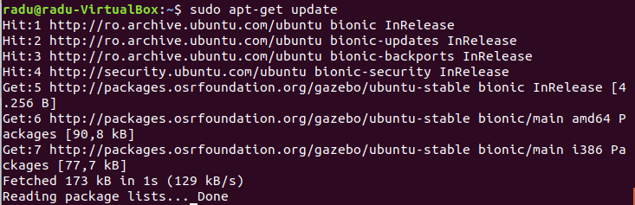

sudo apt-get update

Make sure the update has finished with the message Done.

Next install gazebo-11 by:



sudo apt-get install gazebo11

**2.3 Verify Gazebo installation**

Check your installation



gazebo

After running the command the program should start and it will look like this:

